Compiler Design Sample

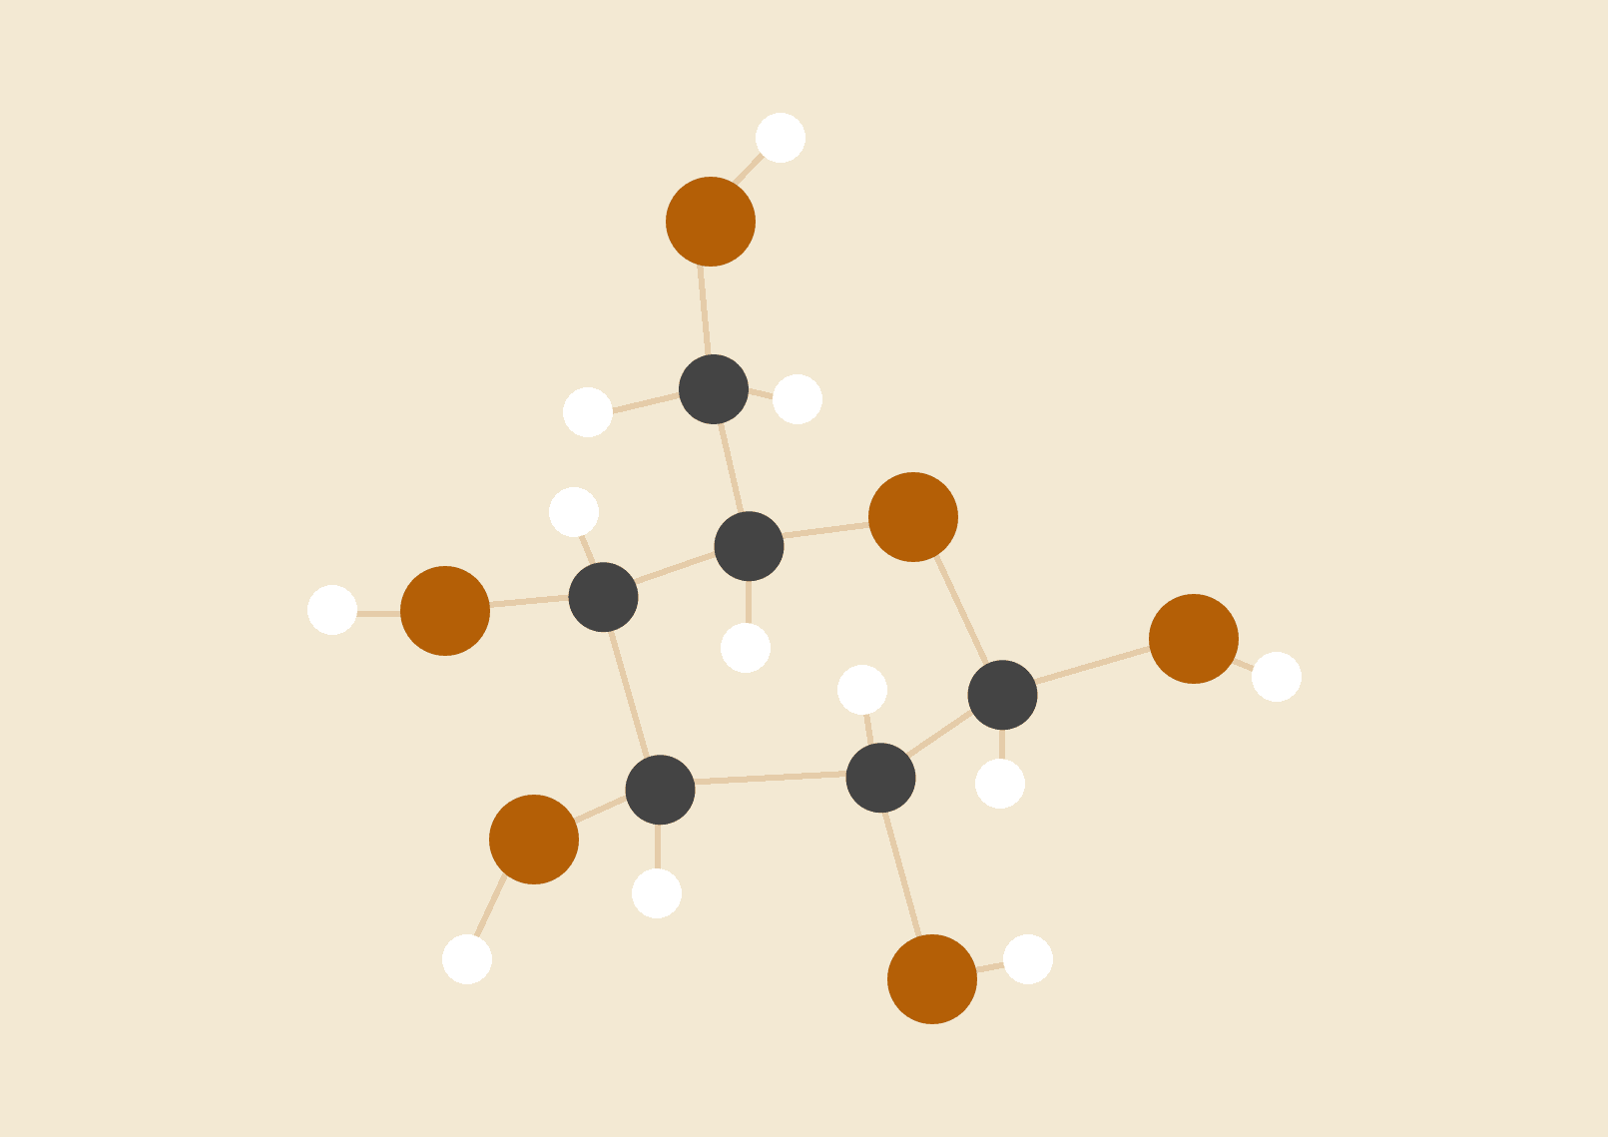

**Josh Stafford**

# Section A

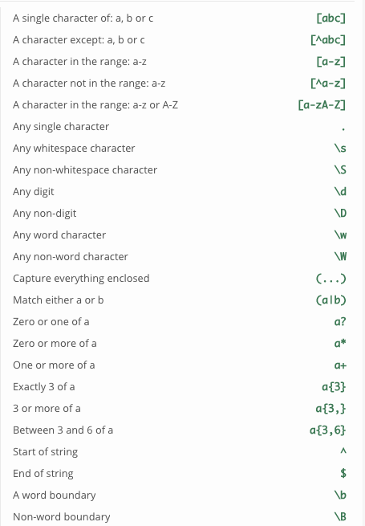

hhh h hh hhhh hhhhhh hhhhh

hhh = 4

Matches hhh literally

YYYq qqqq YYYYY YYYY YY qYY YYYYYY qq qqqqq qqqYYY qqqqqq qqq YYY YYq YYYqqq

q[A-Z]Y = 2

Lowercase q followed by any uppercase once followed by uppercase Y

FFFFFFii bbbFFii FFFFFFiii bbbFiii FFFFFFFF iFF FFFFFbbb bbbbi bbbbbii FFFbbi iiFb ibb bbbib iiiFFb FFiiii

b[a-zA-Z]F = 2

Lower case b followed by any lower or uppercase letter once, followed by uppercase F

Tddduuu dddTddd ddduuudd Tdddd uuuuuu uuuuddd TTTTTTuu TTdddTTT uuTTTT uuddduu uuuddd TuuuT ddud uuduu uuuu

dd[a-zA-Z][a-zA-Z]+u = 3

dd followed by any upper or lowercase letter at least twice followed by lowercase u

jrrrr FjF rFFFF jjFFrrr rFFrr FFFrr jjrF jjjjjFFF rrjjjrr rjjjj rrrjjF rFF rFjj FrrFFF FFFFFFr

r[a-zA-Z][a-zA-Z]?jj = 4

r followed by any uppercase or lowercase letter at least once followed by jj

hhhhLLL LLoooh LLLLLL hhhLLL oooho LLohh ohhho ooohhhhh LLLLLhhh LLLLhh hhhhhhhh oooLLLhh oLLL hhhhooo LhhL

o[a-zA-Z]{1,2}hh = 2

o followed by any upper or lower case letter 1 or 2 times followed by hh

AAfA ffhhA hAAhh hhAAhh fAh hhff AAfff hAf hhfA hhh Ahhhh AAhff hffhh hffh AAh

(f{2,3}|hhh?) = 11

f 2 or 3 times OR at least 2 h’s

Zzzzz zZZZZ zzzmmmmmm mmmZZZZ zZZZz zmmz mmmZZZm mZZ mmmzmm zmmmm zzzmmmm zzmmmmm ZZZmmmmmm Zmmm ZZZZZZZ

..zZ. = 0

Any character twice followed by z then Z then any character.

qvq Qvq vQq vvQ vQv qQv Qqv qqq qqQ Qvv vqq vqQ qqv qvQ qQq

^[a-z] = 12

Any string starting with any lower case letter assuming each on new line

ookkoo Eok EEkkk kEEo kkok koooo ooooE kooEE EEkk kkEEo kooE ooEEEE koo kkkE EoEE

^(k|E|[A-Z]+) = 12

Any string starting with a lowercase k, or an uppercase E or at least one uppercase of any letter assuming all are on new lines

# 

# 

# 

# 

# 

# 

# 

# 

# 

# Section B

EEEEEE EE erQ8in1 EEEEE EEE sentence EEEEEEE EEEE

%token E

%%

sentence: E | E sentence

;

= 6

Can be one E or any amount of E’s

7IExavI M MMM MMMMM sentence MMMMMM MMMM MM

%token M

%%

sentence: M | sentence M

;

= 6

Can be one M or any amount of M’s

sentence hhhhhhhZ hhhhhZZZZ e5iPght hhhhZ hhhhZZZZ hhhhhhhZZ

%token h Z

%%

sentence: sub | sub sentence

sub: h | Z

;

= 6

Can be just one h or Z or else any amount of h’s or Z’s in any order

vvH HH vvvHH vvvvHH vvHHH vvvH vHHH vvHH vH v

%token v H

%% sentence: v | H | v sentence

;

= 10

Just one v or one H or else any amount of v’s followed by one H

iiiAAA iiiiA iiiAA iiiA iAA ii iiA iA iiiAAAA AA

%token i A

%% sentence: i | A | sentence i

;

= 10

Either an i or an A or any amount of i or A’s ending in an i

uuDD uuuD uuDDDD uuD uuDDD D uDDD uuu uDDDD uuuuDD

%token u D

%% sentence: u | D | D sentence

;

= 1

u or a D or else any amount of D’s followed by either a u or D

cccVVVV VV ccccVV cVVV cVVVV ccc cVV cccVV ccccVVVV cccVVV

%token c V

%% sentence: c | V | sentence V

;

= 9

c or V or any amount of c or V’s ending in a V

PP;PPP; PPPPP;P PPPPP P;PPPPPPPP PPP;P PP;PP;P;PP P;PP

%token P

%% sentence: list | sentence list

list: listc ’;’

listc: P | P listc

;

= 1

(Any amount of P’s with a ;) must have ; at the end

Q,QQQ,Q Q,Q,QQ,QQQQ QQQ, Q,QQQ,QQQ QQ,Q,QQQ, QQQQ,QQ,

%token Q

%% sentence: listc | listc ’,’ sentence

listc: Q | Q listc

;

= 3

Any amount of Q’s or else any amount of Q’s then , then any amount of Q’s, must end in a Q not a comma

K,KK,K K,KKK; KK,KK,K,K; KKKK,K, KKKKK,K; KKKK,K

%token K

%% sentence: commal ’;’

commal: listc | listc ’,’ commal

listc: K | K listc

;

= 3

Any amount of K’s or any amount of K’s with a comma then any amount of K’s but must end in a ;